### POST LAB TASK

Design and implement an embedded system to control the intensity of 220V AC light using variable resistor interfaced with controller using TRIAC and Zero Crossing Detector Circuit.

**PROTEUS SIMULATIONS**

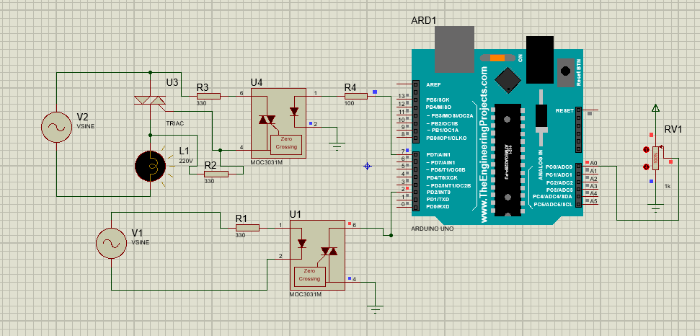

Figure : Minimum Brightness

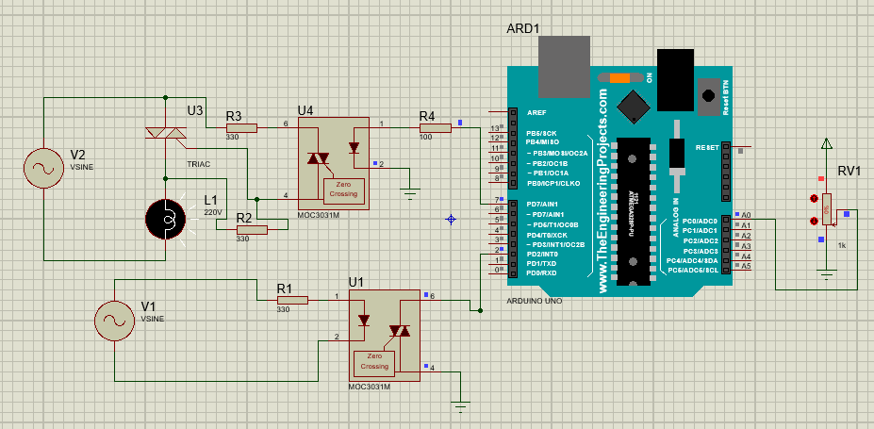

Figure : Maximum Brightness

**ARDUINO IDE CODE:**

|  |
| --- |
| int TRIAC = 7;  int speed_val=0;  void setup()  {  pinMode(TRIAC, OUTPUT);  pinMode(A0,INPUT);  attachInterrupt(digitalPinToInterrupt(2), zero_crossing, CHANGE);  }  void zero_crossing()  {  int chop_time = (200*speed_val);  delayMicroseconds(chop_time);  digitalWrite(TRIAC, HIGH);  delayMicroseconds(10);  digitalWrite(TRIAC, LOW);  }  void loop()  {  int pot=analogRead(A0);  int data1 = map(pot, 0, 1023,10,40);  speed_val=data1;  } |